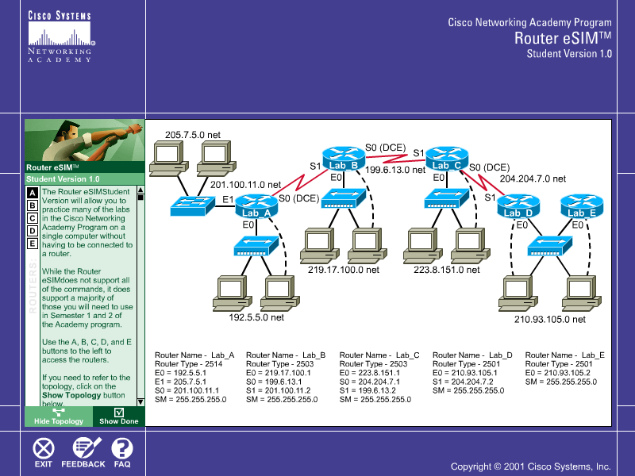
Introduction:
Routers are used to connect networks together. They are able to do this because of two protocols – namely routed protocol (e.g. ip) and routing protocol (here we use routing information protocol). Ip allows logical grouping of computers and devices into networks (or subnetworks), and routers route packets based on the ip address in each packet. Specifically, routers choose the best path to forward the packet towards the destination. Routers are connected to other routers to form interconnecting networks. To perform routing properly, routers must know where the networks are connected to(to which router they are connected). Therefore, routers must exchange routing information among its neighbours. One such protocol is RIP. Once RIP is enabled on the router, and the networks (that the router is connected to) are included in the RIP process, routing information packets are exchanged between neighbour routers. When all connecting routers are configured with RIP, each one will know all the connecting networks and builds route table accordingly. Once RIP is established each network can connect to all other networks connected by the routers. (E.g. one computer can ping another computer.)

In order to establish connectivity among the 5 routers (lab_A to lab_E), you have to configure each of the routers. The parameters needed to be configured are:
- Ip address for each of the interfaces;
- Enable the interfaces
- Routing protocols – here we use RIP.
- Networks addresses that is included in the RIP process.

Configure router Lab_A.
- Getting started
    - router(config)# enable → to get into the privileged mode. (in this mode you can configure the router)

    - router(config)# hostname lab_A → set the name of the router to lab_A

    - router(config)# configure terminal → to enter the configure mode using the terminal.

- You must set the ip address, and etc, for each interface (e0, e1, s0, s1).

Now to configure e0, first tell the router you want to configure e0 by typing:

- router(config)# Interface e0 → to enter the interface configuration mode for e0.

Now, you are in the interface-configuration mode.
Note the prompt has changed to router(config-if)#.
To configure the ip address for e0:
- router(config-if)# ip address 192.5.5.1 255.255.255.0
You also have to enable the interface e0:
- router(config-if)# no shutdown → to turn on the interface

Now for e1:
- router(config)# Interface e1 → to enter the config-mode for e1.
- router(config-if)# ip address 205.7.5.1 255.255.255.0
- router(config-if)# no shutdown

Now for s0:
- router(config)# Interface → to enter the config-mode for s0.
- router(config-if)# ip address 201.100.11.1 255.255.255.0
- router(config-if)# clock rate 56000 → to set to clock speed of comm. link
- router(config-if)# no shutdown

- To enable dynamic routing for Lab_A
First exit the config-if mode, type exit.

Enter the RIP process by typing:

- router(config)# router rip → to enter the config-mode for router-rip.
Note that the prompt has changed to router(config-router)#
For each network connected to the router you must include it in the RIP process:
- router(config-router)# network 192.5.5.0
- router(config-router)# network 205.7.5.0
- router(config-router)# network 201.100.11.0

- Checking the configuration and see what routes are available.
First exit the config-router mode, → exit and exit the config-mode → exit.
Note the prompt has changed to lab_A#

To see the configuration done so far type
- Lab_A# show running-configuration (can use also type show run )
You will see a display of the configuration completed by you so far.
To see what routes are available in the route table type:
- Lab_A# show ip route → displays the route table
What is displayed? What routes do you see? Describe the kind of routes in the table.

Try pinging lab_b e0 → ping 219.17.100.1.
Is the ping successful? _____. Explain the result.

- Lab_A# show ip route → displays the route table
Record down what is displayed.
What kind of routes is in the route table? Explain why other routes are not in the table?

- Using the same commands, complete the ip settings for Lab_B, lab_C, lab_D, and lab_E. Do not configure router rip.
- Try pinging the ip address of different routers,
e.g. from Lab_B, ping 210.93.105.2; from A to C; from B to C….
What are the results? Elaborate.
From A to B : ______________________________________________
Explain:_______________________________________________________
From A to C: _______________________________________________
Explain:_______________________________________________________
From B to E:_____________________________________________________
Explain:_______________________________________________________

- Now configure router rip Lab_B, lab_C, lab_D, and lab_E. As each router is configured with RIP try pinging other routers.
Record the results and explain why it is different.

- Check the route table of Lab_B, and lab_D
  - lab_B# show ip route
Record the result. What kinds of routes are available this time? Explain why other routes are present?

Result:

Types of routes:
Why are they here? What factors contributed to their presence?

